[***http://docs.oracle.com/javase/tutorial/uiswing/components/dialog.htm***](http://docs.oracle.com/javase/tutorial/uiswing/components/dialog.htm)

***import javax.swing.JOptionPane;***

TITLE

TITLE BAR

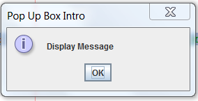

JOptionPane.*INFORMATION_MESSAGE*

Press OK Button or X to exit.

MESSAGE

JOptionPane.showMessageDialog(null, "Display Message", "Pop Up Box Intro ", JOptionPane.*INFORMATION_MESSAGE*);

MESSAGE

TITLE BAR

TITLE

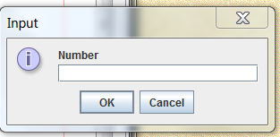

JOptionPane.*INFORMATION_MESSAGE*

Press OK to Accept Input and dismiss dialog

String sample = JOptionPane.showInputDialog(null, "Number", “Input" ,

JOptionPane.*INFORMATION_MESSAGE*);

**null-** the zero-valued ASCII character, also designated by NUL, often used as a terminator, separator or filler

String- character strings. All string literals in Java programs, such as "abc", are implemented as instances of this class.

System.exit(0); -very raw, low-level, and unsafe way to end your program

Parsing Method- is the process of analysing a string of symbols, either in natural language or in computer languages, conforming to the rules of a formal grammar.

int anynumber = Integer.parseInt(sample); - converting the type of string in to Int

Programming Assignment:

Task 1:

Take your program from Assignment 4, Task #2 and change it so the user enters the number of seconds she wants to convert using a JOptionPane.showInputDialog “pop up box” for input. If the user exits out the program by pressing the “X” button, prompt the user with a message and the program should end without an error. Change the program so all outputs are returned in a JOptionPane.showMessageDialog “pop up box”.

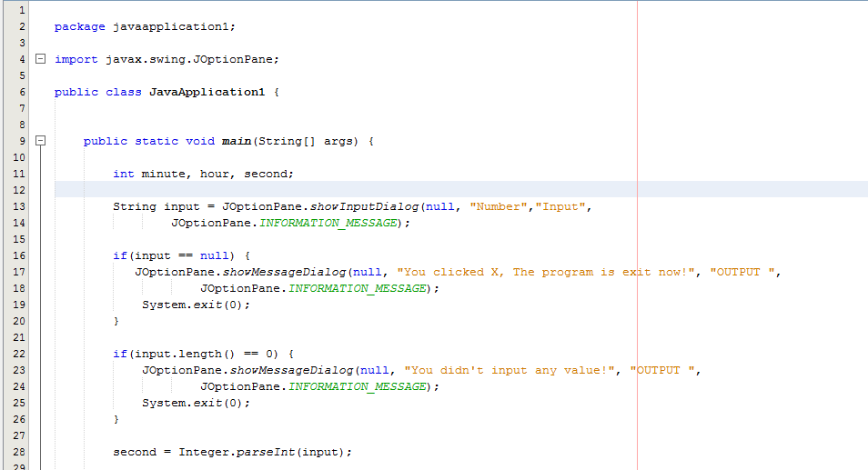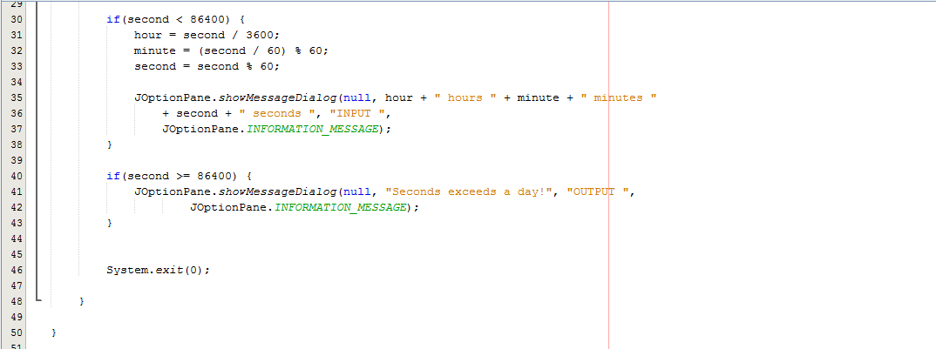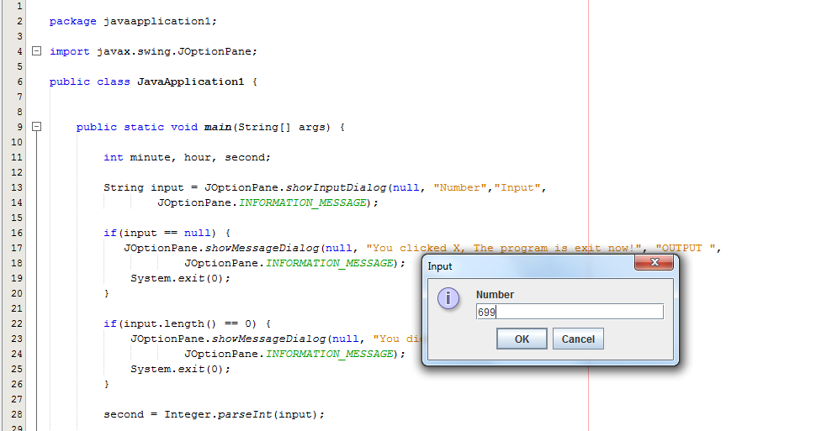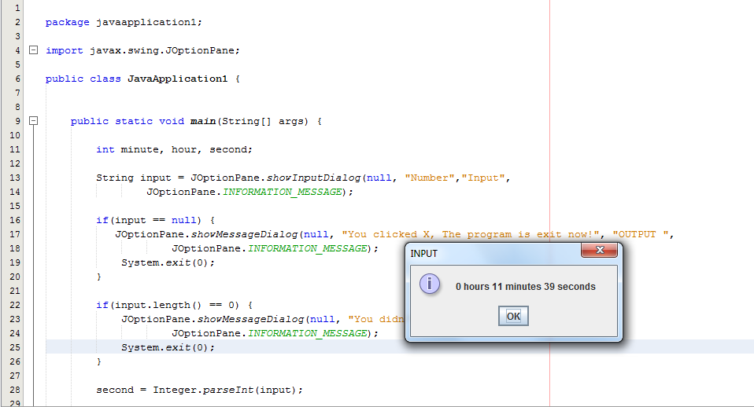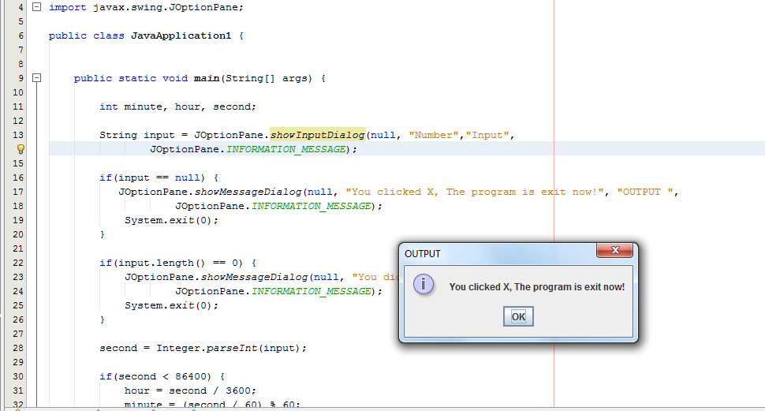

Task 2:

Using **If** and Logical operator statements. Write a program that computes a single filer’s income tax burden.

|  |  |
| --- | --- |
| **TAX RATE** | **Single Filers Income** |
| 10% | Up to $6000 |
| 15% | $6,001 - $27,950 |
| 27% | $27,951 - $67,700 |
| 30% | $67,701 - $141,250 |
| 35% | $141,251 - $307,050 |
| 38.6% | $307, 051 or more |

The user should be able input his data into a JOptionPane.showInputDialog “pop up box”

The output can be a simple system.println output.

Attach Snipping photos displaying output from different tax rates.

Don’t worry about output formatting yet.

